A first-cut diagram is shown in Fig. <$n:figure:FirstCut>

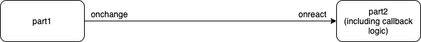
Fig. <$n:figure:FirstCut> First Version of Diagram

This diagram has the "problem" that all callback logic is implicit, probably buried in "part2".

We can pull the callback logic out into a separate component, as in Fig. <$n:figure:SecondCut>:

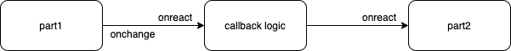
Fig. <$n:figure:SecondCut> Second Version of Diagram

The second diagram shows <$Scr_Cs::0>onreact<!$Scr_Cs::0> as the input pin of, both, the "callback logic" and the "part2" components. This is as intended, but is very JavaScript-y. In fact, every component reacts to the custom <$Scr_Cs::0>onreact()<!$Scr_Cs::0> function in the same way - by calling its own <$Scr_Cs::0>onreact()<!$Scr_Cs::0> function with two arguments - the pin and the data.

Let's refine the diagram to use better pin names in Fig. <$n:figure:ThirdCut>

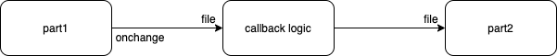
Fig. <$n:figure:ThirdCut> Third Version of Diagram - Better Pin Names

This diagram still has a problem - it does not describe the entire situation. The callback logic has at least 3 possible outcomes -

- success
- error
- no response

and, only (1) outputs a good File descriptor. Let's redraw the diagram with this detail, in Fig. <$n:figure:FourthCut>

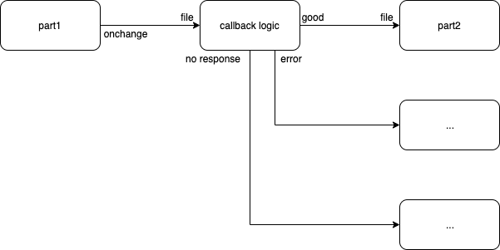
Fig. <$n:figure:FourthCut> Diagram That Shows 3 Callback Outcomes

but, how does "no response" get generated? Answer: a timer component, as in Fig. <$n:figure:FifthCut>:

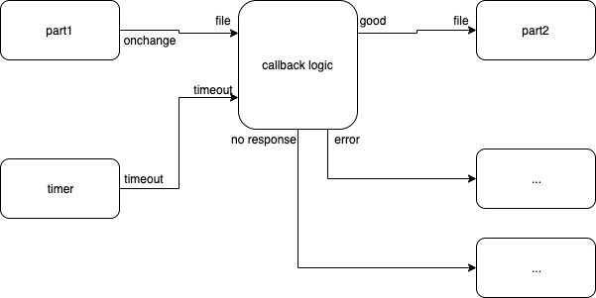
Fig. <$n:figure:FifthCut> Diagram That Shows a Timer Input

If this last diagram looks complicated, remember that this is what needs to be done in JavaScript code, without a diagram, using only text (which, I claim, is even more complicated to understand).

If we wanted to simplify the diagram, we could show only the happy path as in Fig. <$n:figure:ThirdCut>, and lasso the rest of the components - the unhappy path - into various other hierarchical, composite, components.

Better yet, we could invent a programmers' diagram editor that showed layers - different views - of the diagram (e.g. the happy path layer, the error layer, the timeout layer, etc., etc.).

